Earth’s 4 Spheres Name: _________________________________
Hydrosphere
Definition (in Your own Words) | Facts/characteristics
Definition (Picture) | 2 examples of how it interacts with a different sphere  1.  2.

Atmosphere
Definition (in Your own Words) | Facts/characteristics
Definition (Picture) | 2 examples of how it interacts with a different sphere  1.  2.

Lithosphere
Definition (in Your own Words) | Facts/characteristics
Definition (Picture) | 2 examples of how it interacts with a different sphere  1.  2.

Biosphere
Definition (in Your own Words) | Facts/characteristics
Definition (Picture) | 2 examples of how it interacts with a different sphere  1.  2.

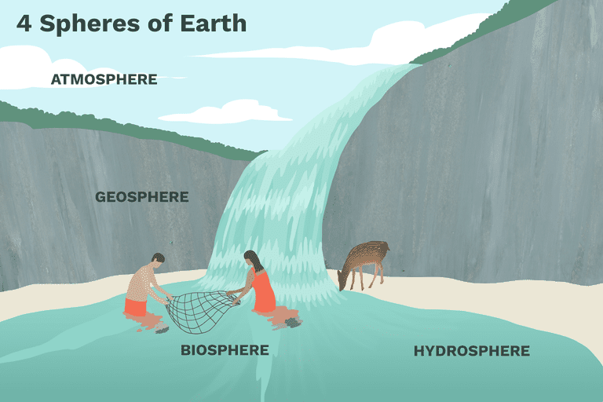
(LITHOSPHERE)
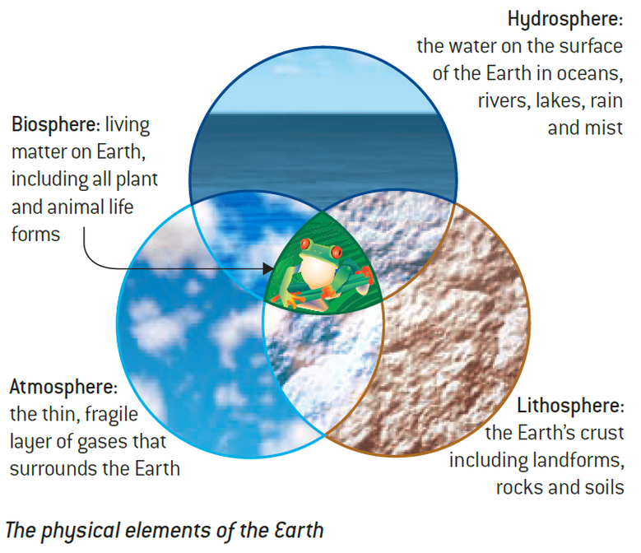

Elements of the Climate System
- Earth’s Spheres
- Bios, Lithos, Hydros, Atmos
- Exploring Earth’s 4 Spheres

The understanding of '-sphere- in this situation means 'to surround or encompass' The following help us understand the mean of the four spheres :
Lithosphere - litho referring to rocks and minerals

It is believed the lithosphere evolved about 4.6 billion years ago. The lithosphere refers to the solid, rocky crust that covers the entire planet. This solid, rocky crust is composed of a number of different rocks that have been grouped into three categories based on how they are formed. These three groups include: Metamorphic rocks, Igneous rocks, snf Sedimentary rocks.
The lithosphere includes a various number of different landforms such as mountains, valleys, rocks, minerals and soil. The lithosphere is constantly changing due to forces and pressures such as the sun, wind, ice, water and chemical changes. The earth’s surface is composed into two types of lithospheres. There are known as the oceanic and continental lithospheres.
Lithosphere
The lithosphere contains all of the cold, hard solid land of the planet's crust (surface), the semi-solid land underneath the crust, and the liquid land near the center of the planet. *The surface of the lithosphere is very uneven (see image at right). There are high mountain ranges like the Rockies and Andes (shown in red), huge plains or flat areas like those in Texas, Iowa, and Brazil (shown in green), and deep valleys along the ocean floor (shown in blue).
The solid, semi-solid, and liquid land of the lithosphere form layers that are physically and chemically different. If someone were to cut through Earth to its center, these layers would be revealed like the layers of an onion (see image above). The outermost layer of the lithosphere consists of loose soil rich in nutrients, oxygen, and silicon. Beneath that layer lies a very thin, solid crust of oxygen and silicon. Next is a thick, semi-solid mantle of oxygen, silicon, iron, and magnesium. Below that is a liquid outer core of nickel and iron. At the center of Earth is a solid inner core of nickel and iron.
*Note: The word "lithosphere" can take on different meanings depending on the speaker and the audience. For example, many geologists--scientists who study the geologic formations of Earth--reserve the word "lithosphere" to mean only the cold, hard surface of Earth, not the entire inside of the planet. For the purpose of this module, however, there will be no distinction among the various layers of land. The word "lithosphere" will be used in reference to all land in Earth's system.
The Lithosphere
The lithosphere, sometimes called the geosphere, refers to all of the rocks of the earth. It includes the planet's mantle and crust, the two outermost layers. The boulders of Mount Everest, the sands of Miami Beach, and the lava erupting from Hawaii's Mount Kilauea are all components of the lithosphere.
The actual thickness of the lithosphere varies considerably and can range from roughly 40 km to 280 km.1﻿ The lithosphere ends at the point when the minerals in the earth's crust begin to demonstrate viscous and fluid behaviors. The exact depth at which this happens depends on the chemical composition of the earth as well as the heat and pressure acting upon the material.
The lithosphere is divided into about 12 major tectonic plates and several minor plates that fit together like a jigsaw puzzle. The main plates include the Eurasian, Indo-Australian, Philippine, Antarctic, Pacific, Cocos, Juan de Fuca, North American, Caribbean, South American, Scotia, and African plates.2﻿
These plates aren't fixed; they're slowly moving. The friction created when tectonic plates push against one another causes earthquakes, volcanoes, and the formation of mountains and ocean trenches.

The understanding of '-sphere- in this situation means 'to surround or encompass'
The following help us understand the mean of the four spheres :
Hydrosphere - hydro referring to water
The hydrosphere refers to the most important resource which I water. The hydrosphere includes all forms of water in the Earth’s environment. The forms of water include things such as the ocean, lakes, rivers, snow and glaciers, water underneath the earth’s surface and even the water vapour that is found in the atmosphere. The hydrosphere is always in motion as seen through the movement and flow of water in rivers, streams and the ocean (beach). Plant and animal organisms rely on the hydrosphere for their survival as water is essential. The hydrosphere is also home to many plants and animals and it believed that the hydrosphere covers approximately 70% of the earth’s surface

Hydrosphere
The hydrosphere contains all the solid, liquid, and gaseous water of the planet. **It ranges from 10 to 20 kilometers in thickness. The hydrosphere extends from Earth's surface downward several kilometers into the lithosphere and upward about 12 kilometers into the atmosphere.
A small portion of the water in the hydrosphere is fresh (non-salty). This water flows as precipitation from the atmosphere down to Earth's surface, as rivers and streams along Earth's surface, and as groundwater beneath Earth's surface. Most of Earth's fresh water, however, is frozen.
Ninety-seven percent of Earth's water is salty. The salty water collects in deep valleys along Earth's surface. These large collections of salty water are referred to as oceans. The image above depicts the different temperatures one would find on oceans' surfaces. Water near the poles is very cold (shown in dark purple), while water near the equator is very warm (shown in light blue). The differences in temperature cause water to change physical states. Extremely low temperatures like those found at the poles cause water to freeze into a solid such as a polar icecap, a glacier, or an iceberg. Extremely high temperatures like those found at the equator cause water to evaporate into a gas.
**Note: Some scientists place frozen water--glaciers, icecaps, and icebergs--in its own sphere called the "cryosphere." For the purpose of this module, however, frozen water will be included as part of the hydrosphere. The word "hydrosphere" will be used in reference to all water in Earth's system.

The Hydrosphere
The hydrosphere is composed of all of the water on or near the planet's surface. This includes oceans, rivers, and lakes, as well as underground aquifers and the moisture in the atmosphere. Scientists estimate the total amount at about 1.3 billion cubic kilometers.
More than 97% of the earth's water is found in its oceans.3﻿ The remainder is freshwater, two-thirds of which is frozen within the earth's polar regions and mountain snowpacks. It's interesting to note that even though water covers the majority of the planet's surface, water accounts for a mere 0.023% of the earth's total mass.4﻿
The planet's water doesn't exist in a static environment, it changes form as it moves through the hydrological cycle. It falls to the earth in the form of rain, seeps into underground aquifers, rises to the surface from springs or seeps from porous rock, and flows from small streams into larger rivers that empty into lakes, seas, and oceans, where some of it evaporates into the atmosphere to begin the cycle anew.
The understanding of '-sphere- in this situation means 'to surround or encompass' The following help us understand the mean of the four spheres :
Biosphere - bio referring to life

The biosphere is composed of all living organisms, including; plants and animals. It is believed that all life exists in the biosphere. Most of the living organisms are found from up to three meters below ground to thirty meters above it and also in the to 200 meters of the ocean and seas. The biosphere could not survive if it wasn't for the other spheres as all organisms need water from the hydrosphere, minerals for the lithosphere and gases from the atmosphere. Energy flow is essential to maintain the structure of organisms by the splitting of phosphate bonds.

Biosphere
The biosphere contains all the planet's living things. ***This sphere includes all of the microorganisms, plants, and animals of Earth.
Within the biosphere, living things form ecological communities based on the physical surroundings of an area. These communities are referred to as biomes. Deserts, grasslands, and tropical rainforests are three of the many types of biomes that exist within the biosphere.
It is impossible to detect from space each individual organism within the biosphere. However, biomes can be seen from space. For example, the image above distinguishes between lands covered with plants (shown in shades of green) and those that are not (shown in brown).
***Note: Some scientists place humans in their own sphere called the "anthrosphere." For the purpose of this module, however, humans will be included as part of the biosphere. The word "biosphere" will be used in reference to all living things in Earth's system.

The Biosphere
The biosphere is composed of all living organisms: plants, animals and one-celled organisms alike. Most of the planet's terrestrial life is found in a zone that stretches from 3 meters below ground to 30 meters above it. In the oceans and seas, most aquatic life inhabits a zone that stretches from the surface to about 200 meters below.5﻿
But some creatures can live far outside of these ranges: some birds are known to fly as high as 7,000 meters above the earth, under certain circumstances.6﻿ On the other side of the spectrum, the Mariana snailfish has been found living at a depth below 6,000 meters in the Marianas Trench.7﻿ Microorganisms are known to survive well beyond even these ranges.
The biosphere is made up of biomes, which are areas where plants and animals of a similar nature can be found together. A desert, with its cactus, sand, and lizards, is one example of a biome. A coral reef is another.

The understanding of '-sphere- in this situation means 'to surround or encompass' The following help us understand the mean of the four spheres :
Atmosphere - atmo referring to steam and vapor

The atmosphere referrers to the air that surrounds the earth. The atmosphere is always in motion and constantly changing. It’s believed that there are about 14 different gases that make up the atmosphere. The atmosphere is also responsible for the weather as the weather occurs within the lower atmosphere.
The bottom layer of the atmosphere is known as the troposphere. The troposphere is where the weather happens. It is the warmest near the Earth because of the heat rising from the earth’s surface but it becomes colder with altitude. This layer is separated from the next by what is known as tropopause. The tropopause is the point in which temperatures will begin to change due to the increase of altitude.
Above the tropopause is the stratosphere. The stratosphere is where there large concentration of ozone gas is found. The ozone gasses are essential as they absorb a large percent of radiant solar energy, protecting the earth from harmful ultra violet rays also known as UV.
The coldest of spheres is known as the mesosphere this is where the water vapor often freezes to create clouds that are purely made of ice. The mesosphere is separated from the thermosphere by the mesopause.
The topmost layer is known as the thermosphere, this is where many satellites circle the earth. Due to the thin air and proximity of the sun, the temperatures in the thermosphere tend to rapidly increase and decrease.

Atmosphere
The atmosphere contains all the air in Earth's system. ****It extends from less than 1 m below the planet's surface to more than 10,000 km above the planet's surface. The upper portion of the atmosphere protects the organisms of the biosphere from the sun's ultraviolet radiation. It also absorbs and emits heat. When air temperature in the lower portion of this sphere changes, weather occurs. As air in the lower atmosphere is heated or cooled, it moves around the planet. The result can be as simple as a breeze or as complex as a tornado.
****Note: The atmosphere is made up of many layers that differ in chemical composition and temperature. For the purpose of this module, however, we will not differentiate among the layers of the atmosphere. The word "atmosphere" will be used in reference to all of the layers.

The Atmosphere
The atmosphere is the body of gasses that surrounds our planet, held in place by earth's gravity. Most of our atmosphere is located close to the earth's surface where it is most dense. The air of our planet is 79% nitrogen and just under 21% oxygen; the small amount remaining is composed of argon, carbon dioxide, and other trace gasses.8
The atmosphere itself rises to about 10,000 kilometers in height and is divided into four zones. The troposphere, where about three-quarters of all atmospheric mass can be found, stretches from about 8 to 14.5 kilometers above the earth's surface. Beyond this lies the stratosphere, which rises to 50 kilometers above the planet. Next comes the mesosphere, which extends to about 85 kilometers above the earth's surface. The thermosphere rises to about 600 kilometers above the earth, then finally the exosphere, the outermost layer. Beyond the exosphere lies outer space.9﻿

